

**A211 SESSION 2021/2022**

**STIA1113 PROGRAMMING GROUP C**

**ASSIGNMENT 1**

**LECTURER NAME : Prof. Madya Dr. Azman B Yasin**

**TOPIC : FOOD**

|  |  |  |
| --- | --- | --- |
| **MATRIC NUMBER** | **NAME** | **SUBTOPIC** |
| 287102 | Ho Jun Han | Bread |
| 287148 | Daniel Fikrey Bin Hairulrizal | Cake |
| 287156 | Ho Wai Kiat | Rice |
| 287194 | Kor Jun Xiang | Desserts |
| 287438 | Nurlailatul Aqilah Binti Nasir | Fruits |

A211_STIA1113_C HO JUN HAN 287102

**BREAD**

**1. Identify the Problem:**

The most common product that is sold in the bakery which is bread. Bread is a staple food prepared from a dough of flour (usually wheat) and water, usually by baking. Throughout recorded history and around the world, it has been an important part of many cultures' diet. It is one of the oldest human-made foods, having been of significance since the dawn of agriculture, and plays an essential role in both religious rituals and secular culture.

Bread is one of the oldest prepared foods. At 30,000 years ago, Europe and Australia revealed starch residue on rocks used for pounding plants. It is possible that during this time, starch is extracted from the roots of plants, such as cattails and ferns, was spread on a flat rock, placed over a fire and cooked into a primitive form of flatbread. The world's oldest evidence of bread-making has been found in a 14,500-year-old Natufian site in Jordan's Northeastern desert. Around 10,000 BC, with the dawn of the Neolithic age and the spread of agriculture, grains became the mainstay of making bread. around 3000 BC. The Egyptians refined the process and started adding [yeast](https://en.wikipedia.org/wiki/Yeast) to the [flour](https://en.wikipedia.org/wiki/Flour) but the Sumerians were already using [ash](https://en.wikipedia.org/wiki/Ash) to supplement the dough as it was baked.

There were multiple sources of [leavening](https://en.wikipedia.org/wiki/Leavening) available for early bread. Airborne yeasts could be harnessed by leaving uncooked dough exposed to air for some time before cooking. The [Gauls](https://en.wikipedia.org/wiki/Gauls) and [Iberians](https://en.wikipedia.org/wiki/Iberians) used the foam skimmed from [beer](https://en.wikipedia.org/wiki/Beer), called [barm](https://en.wikipedia.org/wiki/Barm), to produce "a lighter kind of bread than other peoples" such as [barm cake](https://en.wikipedia.org/wiki/Barm_cake). Parts of the ancient world that drank wine instead of beer used a paste composed of [grape](https://en.wikipedia.org/wiki/Grape) juice and flour that was allowed to begin fermenting, or wheat bran steeped in [wine](https://en.wikipedia.org/wiki/Wine), as a source for [yeast](https://en.wikipedia.org/wiki/Yeast).

The most common source of leavening was to retain a piece of dough from the previous day to use as a form of sourdough [starter](https://en.wikipedia.org/wiki/Bread_starter). The Chorleywood bread process was developed in 1961; it uses the intense mechanical working of dough to dramatically reduce the fermentation period and the time taken to produce a loaf. The process, whose high-energy mixing allows for the use of grain with a lower protein content, is now widely used around the world in large factories. As a result, bread can be produced very quickly and at low costs to the manufacturer and the consumer.

**2. Understand Problem:**

TK Bakery aka “Tong Kee Brothers Confectioner” is established in 1970 after revamping and getting a new name from “Tong Kee Buns and Dim Sum”. TK Bakery mainly producing egg tarts, buns, chicken pies, and mooncakes, sold in a coffee house in Petaling Street. Tong Kee brand’s popularity started to spread like wild fire ever since, and its egg tarts were so famous to many throughout the country. The bakers are required to buy ingredients from the market for making breads whenever the ingredients are inadequate. The bakers have the responsibility for preparing and measuring the quantity of ingredients that are needed for respective breads properly. The price of the ingredients is changing periodically because the price of the ingredients are based on the market price. The cost of the ingredients will affect the price of breads that will be sold in the bakery. Thus, a price calculation system is utilized.

**Ingredients to buy:**

1kg flour for one packet

1kg sugar for one packet

egg for one dozen

11g yeast for one packet

1000ml milk for one carton

250g butter for one packet

chocolate for one bar

500g garlic for one bag

325g buttermilk for one carton

300g red bean for one bag

|  |  |  |
| --- | --- | --- |
| **Bread** | **Ingredient that are needed** | **Cost calculation** |
| Chocolate bread | 1. 0.125 chocolate 2. 115g flour 3. 12.5g sugar 4. 0.5 egg 5. 2.1g yeast 6. 45ml milk 7. 28.75g butter | 0.125*chocolate  + 0.115*flour  + 0.0125*sugar  + 0.5*egg  + 0.19*yeast  + 0.045*milk  + 0.115*butter |
| Garlic bread | 1. 0.1 garlic 2. 105.75g flour 3. 9.5g sugar 4. 0.25 egg 5. 1.875g yeast 6. 12.5ml milk 7. 28g butter | 0.1*garlic  + 0.10575*flour  + 0.0095*sugar  + 0.25*egg  + 0.17*yeast  + 0.0125*milk  + 0.112*butter |
| Butter sugar bread | 1. 11.5g buttermilk 2. 112.5g flour 3. 18.75g sugar 4. 0.25 egg 5. 2.025g yeast 6. 35g butter | 0.035*buttermilk  + 0.1125*flour  + 0.01875*sugar  + 0.25*egg  + 0.185*yeast  + 0.14*butter |
| Red bean bread | 1. 50g red bean 2. 110g flour 3. 15g sugar 4. 0.25 egg 5. 2.1g yeast 6. 25ml milk 7. 20g butter | 0.1675*red bean  + 0.11*flour  + 0.015*sugar  + 0.25*egg  + 0.19*yeast  + 0.025*milk  + 0.08*butter |

*ingredients at this part represent the value of the ingredients

*ingredients at this part represent the value of the ingredients

**3. Alternative Ways:**

1. Amy inserts all the value of the ingredients and then determine the price of bread that will be sold in the bakery.
2. The system will calculate and determine the cost for ingredients, calculate the total cost of the ingredients and determine the price of the bread.

**4. Best Way:**

The first way is the best way because it will fulfilled the problem where the cost of ingredients can be changed based on the market price. The value of the ingredients can be key in correctly and then we can determine the suitable price for the bread that is needed to sell in the bakery. The second way is not good enough to solve the problems because the system will calculate the average cost of the ingredients and the cost of ingredients may be difference with the exact value. Besides that, the system will determine the price of the bread and the price may be will be higher or lower than the normal price of bread.

**5. Instructions:**

1. Get the value of the ingredients that bought from the market
2. Key in the value of the ingredients
3. Calculate the value of the ingredients with respective types of ingredient that have been used for respective bread
4. Display the total cost of the ingredients for each bread after calculating
5. Calculate the price of the breads that will be sold in the bakery
6. Display the price of the breads after getting the total cost of the ingredients.

**6. Evaluate the Solution:**

The solution meets the requirement to solve the problems stated. Firstly, the system will calculate the cost of the ingredients. The cost of each bread will be different from each other because the quantity of the ingredients are used for each bread is different. The cost for each bread will be displayed. Then, the system will calculate the price of the breads which are based on the cost of the ingredients that are used. The final price for each bread will be displayed.

**7. Algorithms:**

**i) Pseudocode: -**

Start

* Declare double flour, double sugar, double egg, double yeast, double milk, double butter, double chocolate, double garlic, double buttermilk, double redbean.
* Output “Enter price of 1kg flour for one packet: ”
* Input price of 1kg flour for one packet
* Output “Enter price of 1kg sugar for one packet: ”
* Input price of 1kg sugar for one packet
* Output “Enter price of egg for one dozen: ”
* Input price of egg for one dozen
* Output “Enter price of 11g yeast for one packet: ”
* Input price of 11g yeast for one packet
* Output “Enter price of 1000ml milk for one carton: ”
* Input price of 1Litre milk for one carton
* Output “Enter price of 250g butter for one packet: ”
* Input price of 250g butter for one packet
* Output “Enter price of chocolate for one bar: ”
* Input price of chocolate for one bar
* Output “Enter price of 500g garlic for one bag: ”
* Input price of 500g garlic for one bag
* Output “Enter price of 325g buttermilk for one carton: ”
* Input price of 325g buttermilk for one carton
* Output “Enter price of 300g red bean for one bag: ”
* Input price of 300g red bean for one bag
* Calculate cost of chocolate bread, garlic bread, butter sugar bread and red bean bread
* Output cost of chocolate bread, garlic bread, butter sugar bread and red bean bread
* Calculate cost of chocolate bread, garlic bread, butter sugar bread and red bean bread
* Output price of chocolate bread, garlic bread, butter sugar bread and red bean bread

End

**ii)Flowchart: -**

Start

Declare double flour, double sugar, double egg, double yeast, double milk, double butter, double chocolate, double garlic, double buttermilk, double redbean.

Input price of 1kg flour for one packet, price of 1kg sugar for one packet, price of egg for one dozen, price of 11g yeast for one packet, price of 1000ml milk for one carton, price of 250g butter for one packet, price of chocolate for one bar, price of 500g garlic for one bag, price of 325g buttermilk for one carton, price of 300g red bean for one bag

Calculate cost of chocolate bread, garlic bread, butter sugar bread, red bean bread

Output cost of chocolate bread, garlic bread, butter sugar bread, red bean bread

Calculate cost of chocolate bread, garlic bread, butter sugar bread, red bean bread

A

A

Output price of chocolate bread, garlic bread, butter sugar bread and red bean bread

Stop

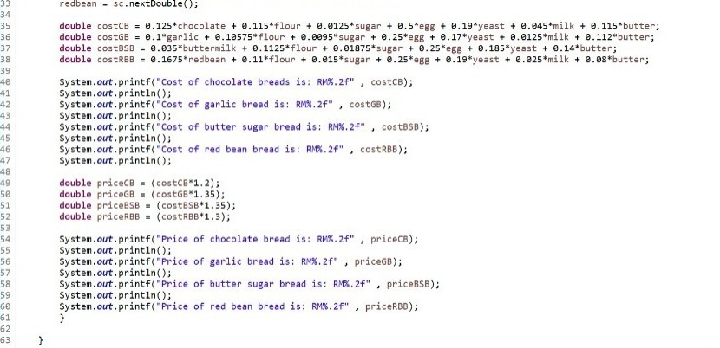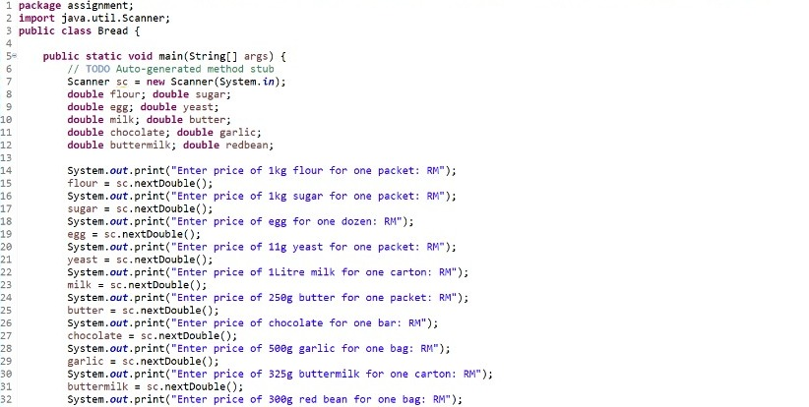**8. Coding:**

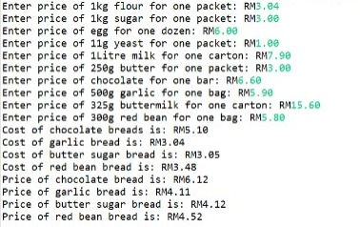

**CAKE DANIEL FIKREY BIN HAIRULRIZAL (287148)**

**PROBLEM**

The history of cake begins from the word of Viking origin, which is ‘kaka’. But for ancient Greeks, the way they call a cake is flat. The ingredients that they use to make a flat is using flour mixed with eggs, milk, nuts and honey. Then during the Roman period, the name of cake become a placenta. The ways to bake a placenta in this period is a bit different which is a placenta was baked on a pastry base or inside a pastry case. In England, cake is essentially with bread but what make it different is the round, flat shape of the cakes and the cooking method. Cake is form of sweet food made from flour, sugar and other ingredients. Cake is very popular food among the people around the world. There are many people who like a cake. Cake also frequently use in many events such as birthday party, weddings, anniversaries and many more. So, many people who open bakery to try make money by selling a cake. There are many types of cake which is pandan cake, red velvet cake, vanilla cake, chocolate cake and many more.

Sarah bakery had trouble getting the ingredients to make chocolate cake every day and they had to buy the ingredients every day. The problem is sometimes the ingredients that they looking for is sufficient but there’s a times when they not getting enough ingredients to make the number of cake that they target on that day and it really disturb their business.

**UNDERSTAND THE PROBLEM**

Sarah bakery is cake seller. The type of cake that they sell is chocolate cake. They have to make the number of chocolate cake base on their target on one day. The problem that Sarah Bakery faces is to get enough ingredients to make chocolate cake that enough for a month. When they not get enough ingredients, it will be a big crisis to them which is they will not able to sell the chocolate on that day. So, their sale will become lower and it really damaging them.

**SOLUTION**

The first way they can use to overcome the problems is not just buy the ingredient in one store but many store every day. For example, if in Samad store is out of flour they just can buy at other store which is the store that has the sufficient flour to make target chocolate cake in that day. So, with this way it will solve the problems that they face.

The other ways are by calculate the ingredients that enough for one month so the store can get enough time to prepare it and send it to the bakery. For example, Sarah bakery calculate the enough ingredients to make chocolate cake for their target for a month and just send the list to the store they want and it can be sure they will not face the problems which is not have enough ingredients to make chocolate cake every day.

**BEST SOLUTION**

The best solution is by calculate the ingredients that enough for one month. This is because it will safe enough time by just order the ingredients and they will send to the bakery. If use the way that buy the ingredients in many stores every day, it will take a lot of time and the time we use for it we can use it at more important things such as clean the bakery, make the extra cake if the cake in sold out for that day and anything else. So, it clearly that by order the ingredients that enough for one month for one time is the best solution.

**INSTRUCTION**

Ask for the number of making chocolate cake for a day

Ask the mass of flour, eggs, sugar, baking powder, ovalette and chocolate for making one cake

Ask the stock of flour, eggs, sugar, baking powder, ovalette, chocolate remaining

The number of cakes for a month = The number of making cake for a day * 30 days

Total mass of flour = The number of cakes for a month * mass of flour

Total number of eggs = The number of cakes for a month * number of eggs

Total mass of sugar = The number of cakes for a month * mass of sugar

Total mass of baking powder = The number of cakes for a month * mass of baking powder

Total mass of ovalette = The number of cakes for a month * mass of ovalette

Total mass of chocolate = The number of cakes for a month * mass of chocolate

Final mass of flour = (Total mass of flour – flour stock)

Final number of eggs = (total number of eggs – egg stock)

Final mass of sugar = (Total mass of sugar – sugar stock)

Final mass of baking powder = (total mass of baking powder – baking powder stock)

Final mass of ovalette = (total mass of ovalette – ovalette stock)

Final chocolate = (total mass of chocolate – chocolate stock)

Display the final weight of flour, eggs, baking powder and ovalette that must add

**EVALUATE SOLUTION**

The solution that user get from the programme will be really accurate about the mass or number of ingredients. When the user uses this programme, it will ease their work which is this programme will help the user to calculate the mass or number of the ingredients that they need for one month. So, it will help them to solve the problems that they face and can continue their sale without worrying their ingredients out of stock. Also with this programme, it will help maintain their income by prepare the sufficient ingredients to make the number of making cake for a month.

**ALGORITHM**

1. Start
2. Enter the target of making a cake for one day.
3. Enter the mass of flour for making one cake in kg.
4. Enter the number of eggs for making one cake in kg.
5. Enter the mass of sugar for making one cake in kg.
6. Enter the mass of baking powder for making one cake in kg.
7. Enter the mass of ovalette for making one cake in kg.
8. Enter the mass of chocolate for making one cake in kg.
9. Enter the mass of flour stock remaining
10. Enter the number of eggs stock remaining
11. Enter the mass of sugar stock remaining
12. Enter the mass of baking powder stock remaining
13. Enter the mass of ovalette stock remaining
14. Enter the mass of chocolate stock remaining
15. The programme will calculate the number of cakes for a month
16. The programme will calculate the total mass of ingredient by multiply mass of ingredient with the number of cakes for a month
17. The programme will calculate the final mass of ingredient by minus total mass ingredient with the mass of stock remaining
18. The programme will display the final mass of ingredient that must add
19. Stop

**PSEUDOCODE**

Start

Output “Please enter the number of making cake in one day”

Input the number of making cake in one day

Output “Enter the mass of flour for making one cake in kg”

Input the mass of flour for making one cake in kg”

Output “Enter the number of eggs for making one cake”

Input the number of eggs for making one cake

Output “Enter the mass of sugar for making one cake in kg”

Input the mass of sugar for making one cake in kg

Output “Enter the mass of baking powder for making one cake in kg”

Input the mass of baking powder for making one cake in kg

Output “Enter the mass of ovalette for making one cake in kg”

Input the mass of ovalette for making one cake in kg

Output “Enter the mass of chocolate for making one cake in kg”

Input the mass of chocolate for making one cake in kg

Output “Enter the mass of flour stock remaining in kg”

Input the mass of flour stock remaining in kg

Output “Enter the number of eggs stock remaining”

Input the number of eggs stock remaining

Output “Enter the mass of sugar stock remaining in kg”

Input the mass of sugar stock remaining in kg”

Output “Enter the mass of baking powder stock remaining”

Input the mass of baking powder remaining

Output “Enter the mass of ovalette stock remaining”

Input the mass of ovalette stock remaining

Output “Enter the mass of chocolate stock remaining”

Input the mass of chocolate stock remaining

Calculate the number of cakes for a month = the number of cakes for a day * 30

Calculate total mass of flour = mass of flour * number of cakes for a month

Calculate total number of eggs = number of eggs * number of cakes for a month

Calculate total mass of sugar = mass of sugar * number of cakes for a month

Calculate total mass of baking powder = mass of baking powder * number of cakes for a

month

Calculate total mass of ovalette = mass of ovalette * number of cakes for a month

Calculate total mass of chocolate = mass of chocolate * number of cakes for a month

Calculate final mass of flour = total mass of flour – mass of flour stock remaining

Calculate final number of eggs = total number of eggs – number of eggs stock remaining

Calculate final mass of sugar = total mass of sugar – mass of sugar stock remaining

Calculate final mass of baking powder = total mass of baking powder – mass of baking powder

stock remaining

Calculate final mass of ovalette = total mass of ovalette – mass of ovalette stock remaining

Calculate final mass of chocolate = total mass of chocolate – mass of chocolate stock

remaining

Output final mass of flour

Output final number of eggs

Output final mass sugar

Output final mass of baking powder

Output final mass of ovalette

Output final mass of chocolate

Stop

**FLOWCHART**

Start

Input the number of making cake in one day

Input the mass of flour for making one cake in kg

Input the number of eggs for making one cake in kg

Input the mass of sugar for making one cake in kg

Input the mass of baking powder for making one cake in kg

Input the mass of ovalette for making one cake in kg.

.

.

Input the mass of chocolate for making one cake in kg

Input the mass of flour stock remaining in kg

Input the number of eggs stock remaining

Input the mass of sugar stock remaining in kg

Input the mass of baking powder stock remaining in kg

Input the mass of chocolate stock remaining in kg

Input the mass of ovalette stock remaining in kg

The number of cakes for a month = the number of cakes for a day * 30

Total mass of flour= mass of flour * the number of cakes for a month

Total mass of chocolate = mass of chocolate * the number of cakes for a month

Total mass of baking powder = mass of baking powder * the number of cakes for a month

Total mass of sugar = mass of sugar * the number of cakes for a month

Total number of eggs = number of eggs * the number of cakes for a month

Total mass of ovalette = mass of ovalette * the number of cakes for a month

Final mass of ovalette = total mass of ovalette – mass of ovalette stock remaining

Final mass of baking powder = total mass of baking powder – mass of baking powder stock remaining

Final mass of sugar = total mass of sugar – mass of sugar stock remaining

Final number of eggs = total number of eggs – number of eggs stock remaining

Final mass of flour = total mass of flour – mass of flour stock remaining

Output final number of eggs

Output final mass of flour

Final mass of chocolate = total mass of chocolate – mass of chocolate stock remaining

Output final mass of sugar

Output final mass of baking powder

Output final mass of ovalette

..

Stop

Output final mass of chocolate

.

.

.

..

.

.

**CODING**

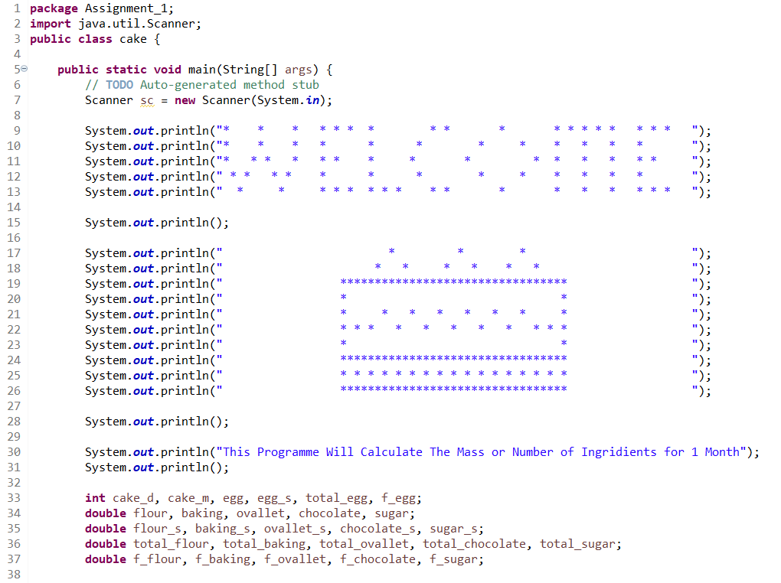

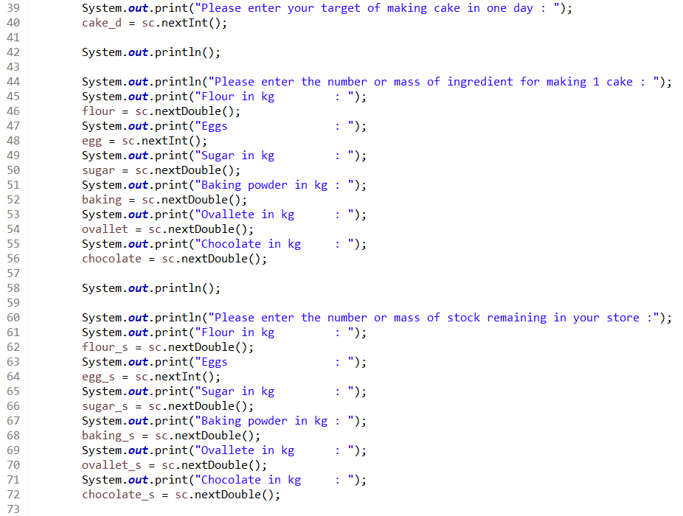

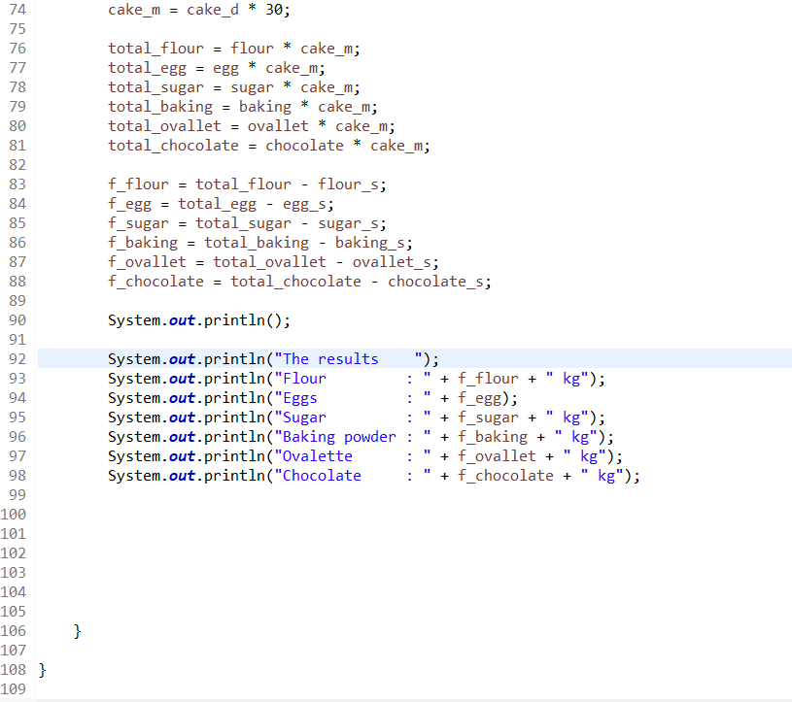

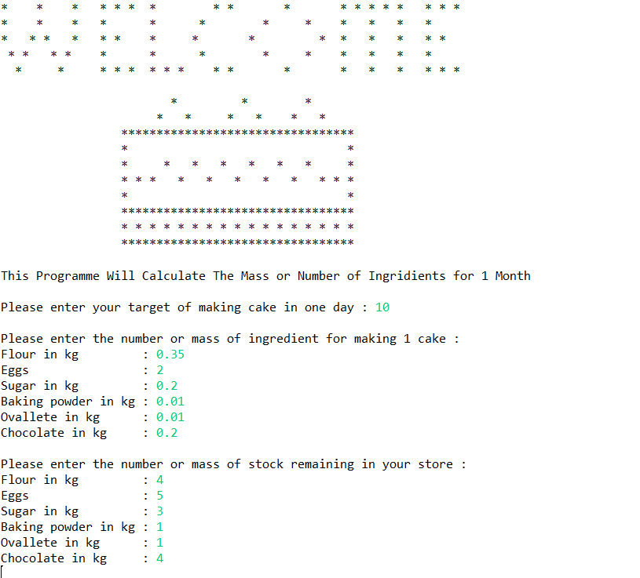

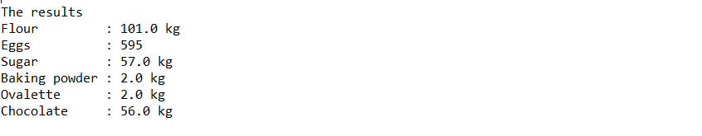

**Rice HO WAI KIAT (287156)**

**Identify the problem**

* Backgroud of the rice
* Definition of rice

Rice is the seed of the grass species Oryza sativa (Asian rice) or less commonly Oryza glaberrima (African rice). The name wild rice is usually used for species of the genera Zizania and Porteresia, both wild and domesticated, although the term may also be used for primitive or uncultivated varieties of Oryza.

As a cereal grain, domesticated rice is the most widely consumed staple food for over half of the world's human population,especially in Asia and Africa. It is the agricultural commodity with the third-highest worldwide production, after sugarcane and maize.Since sizable portions of sugarcane and maize crops are used for purposes other than human consumption, rice is the most important food crop with regard to human nutrition and caloric intake, providing more than one-fifth of the calories consumed worldwide by humans.There are many varieties of rice and culinary preferences tend to vary regionally.

The traditional method for cultivating rice is flooding the fields while, or after, setting the young seedlings. This simple method requires sound irrigation planning but reduces the growth of less robust weed and pest plants that have no submerged growth state, and deters vermin. While flooding is not mandatory for the cultivation of rice, all other methods of irrigation require higher effort in weed and pest control during growth periods and a different approach for fertilizing the soil.

Rice, a monocot, is normally grown as an annual plant, although in tropical areas it can survive as a perennial and can produce a ratoon crop for up to 30 years.Rice cultivation is well-suited to countries and regions with low labor costs and high rainfall, as it is labor-intensive to cultivate and requires ample water. However, rice can be grown practically anywhere, even on a steep hill or mountain area with the use of water-controlling terrace systems. Although its parent species are native to Asia and certain parts of Africa, centuries of trade and exportation have made it commonplace in many cultures worldwide. Production and consumption of rice is estimated to have been responsible for 4% of global greenhouse gas emissions in 2010.

* Rice varieties

There are several grains called "rice": they have been cultivated for thousands of years. There are a huge number of varieties.

Asian rice (Oryza sativa) is most widely known and most widely grown, with two major subspecies and over 40,000 varieties. Also notable are varieties of African rice (Oryza glaberrima) and wild rice (genus Zizania). Rice may vary in genetics, grain length, color, thickness, stickiness, aroma, growing method, and other characteristics.

Rice can be divided into different categories on the basis of each of its major characteristics. The two subspecies of Asian rice, indica and japonica have different length and stickiness. Indica rice is long-grained and unsticky, while japonica is short-grained and sticky.

For instance, over nine major varieties of rice exist for the purpose of making sake alone.The rice plant can grow to 1–1.8 m (3–6 ft) tall, occasionally more depending on the variety and soil fertility. It has long, slender leaves 50–100 cm (20–40 in) long and 2–2.5 cm (3⁄4–1 in) broad. The small wind-pollinated flowers are produced in a branched arching to pendulous inflorescence 30–50 cm (12–20 in) long. The edible seed is a grain (caryopsis) 5–12 mm (3⁄16–15⁄32 in) long and 2–3 mm (3⁄32–1⁄8 in) thick.

**Understand the problem**

* **Yield calculation**

Rice is a major food staple and a mainstay for the rural population and their food security. It is mainly cultivated by small farmers in holdings of less than one hectare. Rice is also a wage commodity for workers in the cash crop or non-agricultural sectors. Rice is vital for the nutrition of much of the population in Asia, as well as in Latin America and the Caribbean and in Africa; it is central to the food security of over half the world population.

Many rice grain producing countries have significant losses post-harvest at the farm and because of poor roads, inadequate storage technologies, inefficient supply chains and farmer's inability to bring the produce into retail markets dominated by small shopkeepers. A World Bank – FAO study claims 8% to 26% of rice is lost in developing nations, on average, every year, because of post-harvest problems and poor infrastructure. Some sources claim the post-harvest losses exceed 40%.Not only do these losses reduce food security in the world, the study claims that farmers in developing countries such as China, India and others lose approximately US$89 billion of income in preventable post-harvest farm losses, poor transport, the lack of proper storage and retail. One study claims that if these post-harvest grain losses could be eliminated with better infrastructure and retail network, in India alone enough food would be saved every year to feed 70 to 100 million people.Therefore,the farmer need to planning with calculate the yield of the rice to prevent the ineffient supply

Through analysis of comparative yields, the farmer and/or extension agent can determine which of the available rice varieties is best suited to local swamp systems and farming practices and keep track of local yields for purposes of comparison and planning. Farmers are generally very shrewd at estimating yields, but they rarely quantify their estimations into standardized units of measurement.

* **Problem**

H & H Food Corp Sdn Bhd is a rice company. They have to ensure that the yield of the rice can always meet market demand every time. Therefore, the yield of each type of rice needs to be calculated strictly to ensure that it does not inefficient supply. However, market demand is often affected by many factors, and yield of the rice will also change. H & H Food Corp Sdn Bhd has a large arable land, and it would take a long time to calculate the yield by manpower .So H & H Food Corp Sdn Bhd needs to make calculations based on the area of the farm to planning the sales and the inventory.

**Identify alternative ways to solve the problem**

* **Farmers' Estimations**

Farmer may be unable to perform mathematical computations, who after years and years of growing rice tend to become shrewd economists in their own right. Farmers pay very careful attention to yields (their livelihood and in fact their very survival depend on them), and although often they develop their own particular system of accounting, generally they know exactly how each crop yielded relative to other crops grown in other years. Some farmers count the number of bundles harvested, others keep track of numbers of bags filled, still others measure in terms of bushels of grain. Whatever the methodology, the farmer ends up with a pretty good idea of how well the crop yielded, and this information helps in planning for the future.

The extension agent requires a more quantitative and standardized method. It is important that yield calculations be quantitative (expressible in precise numbers) so that actual values may be compared from swamp to swamp, year to year, variety to variety. It is important that the method be standardized so that in every case measurement is made in exactly the same way.

* **Yield Calculation**

Since the method of yield calculation described below requires a certain amount of mathematics, it will not always be possible to teach it to farmers. Nor will this be necessary, since for their own accounting purposes farmers can perfectly well continue to rely on their time-tried methods. However, it may be a good idea to teach the method to other extension agents. As agriculturalists, they will be working in more than just one farming system, and it will be useful for them to know how to calculate yields for comparative purposes.

**Select the best way to solve the problem from the list of alternative solution.**

* **Yield Calculation**

Accuracy of yield calculation depends upon an adequate number of counts being taken so as to get a representative average of the paddock. The yield calculation determined will only be a guide and assumptions made from the estimates contain a degree of uncertainty.

This type of yield calculation is one of the easiest and quickest to complete and should be able to be used in a number of situations on a grain growing property. Grain losses both before and during harvest can be significant and an allowance for 5 to 10% loss should be included in your final calculations.

If taken exactly as described above, the sample will contain the yield of 10 m2 of the total crop area. Since yields are generally expressed in terms of kg/ha (kilograms of grain per hectare), the problem now is to convert the yield figures derived from the sample (kg/10 m2) into the standard units of measurement (kg/ha). Since

1 ha = 10000 m2, the sample area constitutes 10/1000 ha, or 1/1000 ha.

Therefore, to determine the average crop yield in kg /ha simply multiply the weight of the sample by 1000.

Example: Careful sampling of ten 1 m2 "mini-samples" results in 550g (.55 kg) of dry grain. What is the yield of the crop in terms of kg/ha?

Weight of sample =.55 kg

Area of sample = 10 m2

Yield in kg/ha =.55 kg/10m2 x 1000 = 550 kg/ha.

|  |  |
| --- | --- |
| 1 kg = 2.2 lbs | 1 ha = 10000 m2 |
| 1 lb = 0.453 kg | 1 ha = 2.47 acres |
| 1 bushel = 60 lbs | 1 acre = 43560 f2 |
| 1 bushel = 27.18 kg | 1 acre = 0.405 ha |

**List Instruction**

1. Determine the yield of the each different type of the rice in sample unit (kg/ 10m2 ).

* Black rice
* Jasmine rice
* Brown rice
* Red cargo rice
* Sticky rice
* Long grain white rice

2. Calculate the area of farm of each type of rice.

3. Convert the yield unit

**Evaluate the solution**

Based on the solution, H & H Food Corp Sdn Bhd can determine the yield of the each type of rice accurately.The harvesting and production of the rice may take a few month,so it cannot waste a long time to calculate the yield.Due to the calculation formula,the farmers can easily order seeds and hire employees by knowing what the yield needs.

**Algorithm**

Start

Enter the weight of each type of rice in sample unit

Enter the area of the farm

Calculate the yield

Convert the unit

End

**Pseudocode**

Program start

Scanner input

Please enter the weight in sample unit(kg/10m2)

Enter the weight of Black rice:

Enter the weight of Jasmine rice:

Enter the weight of Brown rice:

Enter the weight of Red Cargo rice:

Enter the weight of Sticky rice:

Enter the weight of Long grain white rice:

Please enter the area of the farm of each type of rice (hectare)

Enter the area of Black rice farm:

Enter the area of Jasmine rice farm:

Enter the area of Brown rice farm:

Enter the area of Red Cargo rice farm:

Enter the area of Sticky rice farm:

Enter the area of Long grain white rice farm:

Run output

System.out.println

The formula of kg/ha is kg/10m2 x 1000 = kg/ha

The formula of kg is kg/ha x hectare = kg

The yield of each type of rice in kg

Black rice : kg

Jasmine rice : kg

Brown rice : kg

Red Cargo rice : kg

Sticky rice : kg

Long grain white rice : kg

The formula of 1 kg/ha is 2.2lbs/ha

The formula of lbs is lbs/ha x hectare = lbs

The yield of each type of rice in lbs

Black rice : lbs

Jasmine rice : lbs

Brown rice : lbs

Red Cargo rice : lbs

Sticky rice : lbs

Long grain white rice : lbs

**Flow chart**

Convert to other unit

Calculate the yield with formula

Enter the area of the farm

Enter the weight of each rice in sample unit

Coding-Numerical computation and Expression

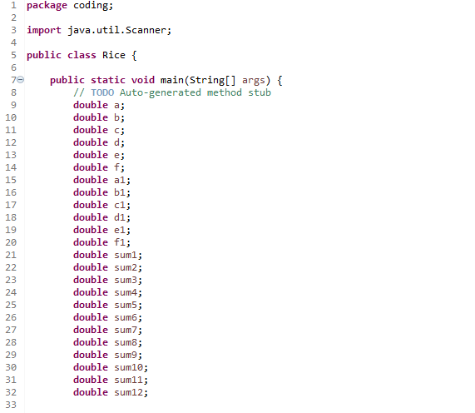

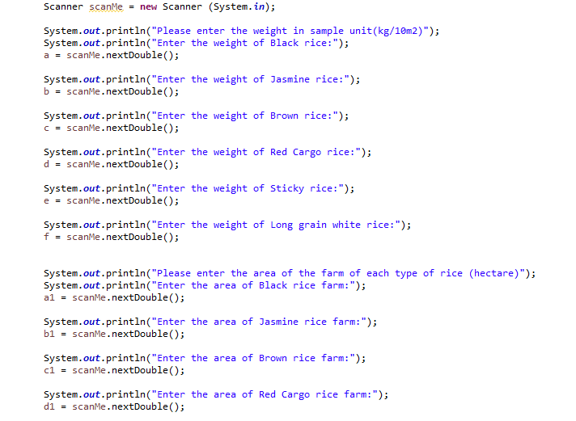

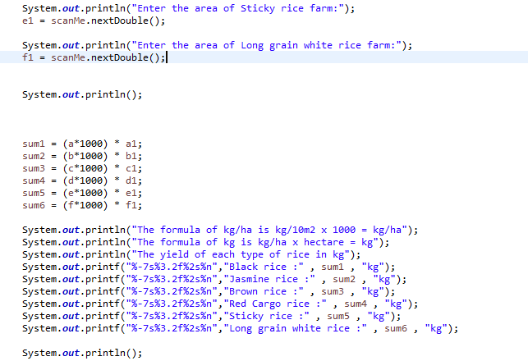

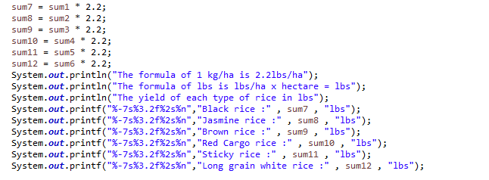

**1. IDENTIFY THE PROBLEM**

Desserts – Kor Jun Xiang(287194)

Dessert is a [course](https://en.wikipedia.org/wiki/Course_(food)) that concludes a meal. The course consists of sweet foods, such as [confections](https://en.wikipedia.org/wiki/Confections), and possibly a beverage such as [dessert wine](https://en.wikipedia.org/wiki/Dessert_wine) and [liqueur](https://en.wikipedia.org/wiki/Liqueur). There is no tradition of a dessert course to conclude a meal in some parts of the world such as much of [Central Africa](https://en.wikipedia.org/wiki/Central_Africa),[West Africa](https://en.wikipedia.org/wiki/West_Africa) and most parts of [China](https://en.wikipedia.org/wiki/China). The word dessert can be applied to many types of confections, such as cakes, biscuits, cookies, puddings, custards, macarons, pastries, etc. Fruits is also commonly found in dessert courses because of its naturally occurring sweetness.

There are a lot of ingredients used in produce a dessert. In example, cakes is a type of desserts that made with sugar and delicate flour, cakes can vary from light, airy sponge cakes to dense cakes with less flour. Cake also has many flavorings like dried, candied or fresh fruits, nuts, cocoa or extracts. They may be filled up with many different fruits preserve and dessert sauce, butter icing and decorated by candied fruits, marzipan and others. For other example like puddings, puddings are similar to custard in their base is creme or milk, their primary difference is that puddings are thickened with starches such as [corn starch](https://en.wikipedia.org/wiki/Corn_starch) or [tapioca](https://en.wikipedia.org/wiki/Tapioca_pudding). On the other hand, custards are thickened using only eggs and are usually firmer. Puddings also have some flavourings like chocolate sauce, strawberry sauce and others drizzle on the top before eating it.

The market for dessert has grown over the last few decades, which was greatly increased by the commercialism of baking desserts and the rise of food productions. There is many different types of desserts shop has been established now in Malaysia such as Mykori Dessert Cafe, Dessert-Hunting, Joslyn Cakes, llao llao, Dáo Desserts and others. There all have their unique desserts and design of the shop to attract customers. Katey has open a dessert shop and she faced the problem that her shop can be operated or not which mean the dessert shop can be able to bring profits to her or not.

**2. UNDERSTANDING THE PROBLEM**

The problem that Katey faced is that the dessert shop she opened was able to bring profits or loss to her. As we see the problem, when a person opens a shop, he or she will need to know the profit or loss after a month of the shop operated, this is important because it mean that your shop can be operated in long term or short term. If the shop brings profits to you, you can operate it in long time as you have the money to operated it. If the shop incapable to bring profits to you, as the time go, when you spend all the money into the shop and then you may face bankrupt of the shop. So, we need to know how to calculate the net profits of the shop gain as the net income earned by Katey.

**3. IDENTIFY THE ALTERNATIVE WAYS**

1. A system was created to help Katey to solve her problem, this system needs Katey to record the total quantity of desserts sold of the month and enter it into the system, she will also enter the price and cost of ingredients for each desserts, the system will calculate the average cost of ingredients and use it to calculate the total cost of ingredients for all desserts by multiply total quantity of desserts sold with the average cost of ingredients, then the system will calculate out the total gross profit by using total sales minus total cost of ingredients. Total up all other costs of the month which are rent, total employee salary, utilities fee and transport fee. At last, system will calculate net income of the month by using total gross profit minus total other costs.

2. A system with different calculation was created to help Katey to solve her problem, this system also needs Katey to record the quantity of each dessert sold of the month and enter the price and cost of ingredients for each dessert. The system will automatically calculate the gross profit for each type of dessert. After that, system will calculate the total gross profit earned of the month by multiply the quantity for each type of desserts sold of the month with their gross profit. System will also calculate total other costs by total up other costs of the month which are rent, total employee salary, utilities fee and transport fee. At last, system will calculate net income of the month by using total gross profit minus total other costs.

**4. BEST WAY TO SOLVE THE PROBLEM**

The second solution is the best way to solve the problem because the result come out is more accurate compared to first solution because it calculates the gross profit and cost of ingredients for each type of desserts to get the result. Compared to the first solution use the average cost of ingredients of all desserts, that will cause a problem that some desserts have the higher profit and some gain low profit, so if the quantity of desserts sold out with the low profit is way more the desserts with the high profit, the profits gain will be lower than the calculation using average cost of ingredients. Mean that the result of the first solution is inaccurate. So, the second way will be the best way to help Katey to solve her problem that calculate the net income.

**5. INSTRUCTION**

1. Katey need to enter the type of dessert sells in her dessert shop.

2. Katey need to enter the price and the cost of ingredients for each type of desserts.

3. The system will calculate the gross profit for each type of desserts.

4. Katey need to enter the quantity of each type of desserts sold of the month.

5. The system will calculate the total cost of ingredients and the total gross profit earned by Katey of the month.

6. Katey need to enter the number of employees , employee salary, rent, utilities fee and transport fee of the month.

7. The system will calculate the total employee salary and total up it with rent, utilities fee and transport fee and get total other costs.

8. System will automatically calculate the net income earned by Katey of the month using the total gross profit minus total other costs.

9. After all calculation, the system will display all the information of Katey operating the desserts shop.

**CALCULATION TABLE :**

|  |  |
| --- | --- |
| **TYPE OF DESSERT** | **A , B , C , D , E** |
| **GROSS PROFIT** | **PRICE – COST OF INGREDIENTS** |
| **TOTAL GROSS PROFIT** | **(QUANTITY * GROSS PROFIT) DO IT FOR ALL TYPES OF DESSERTS AND TOTAL IT UP** |
| **TOTAL SALES** | **QUANTITY * PRICE** |
| **TOTAL COST OF INGREDIENTS** | **(QUANTITY * COST OF INGREDIENTS) DO IT FOR ALL TYPES OF DESSERTS AND SUM IT UP** |
| **TOTAL EMPLOYEE SALARY** | **NUMBER OF EMPLOYEES * EMPLOYEE SALARY** |
| **OTHER COSTS** | **RENT + UTILITIES FEE + TRANSPORT FEE + TOTAL EMPLOYEE SALARY** |
| **NET INCOME** | **TOTAL GROSS PROFIT – TOTAL COST** |

**EXAMPLE OF CALCULATION :**

|  |  |  |  |  |  |  |
| --- | --- | --- | --- | --- | --- | --- |
| Type of desserts | A | B | C | D | E |  |
| Price (RM) | 150 | 90 | 70 | 50 | 35 |  |
| Cost of ingredients (RM) | 50 | 35 | 30 | 18 | 11 |  |
| Gross profit (RM) | 100 | 55 | 40 | 32 | 24 |  |
| Quantity sold | 125 | 145 | 150 | 145 | 160 |  |
|  |  |  |  |  |  | **SUM** |
| Total Sales (RM) | 18750 | 13050 | 10500 | 7250 | 5600 | 55150 |
| TOtal cost of ingredients (RM) | 6250 | 5075 | 4500 | 2610 | 1760 | 20195 |
| Total gross profit (RM) | 12500 | 7975 | 6000 | 4640 | 3840 | 34955 |

|  |  |  |  |
| --- | --- | --- | --- |
| Employee salary | Number of employees | Salary per month | SUM |
|  | 2 | RM 1500 | RM 3000 |

|  |  |  |  |  |  |
| --- | --- | --- | --- | --- | --- |
| Other costs | Rent | Employee salary | Utilities fee | Transport fee | SUM |
|  | RM 1200 | RM 3000 | RM 1000 | RM 500 | RM 5700 |

|  |  |  |
| --- | --- | --- |
| NEt income | 34955-5700 | RM 29255 |

**6.0 EVALUATE THE SOLUTION**

By using the second solution, the results come out is accurately and you can make a change of the data every times you using the system, it is a lot easier to calculate the financial system of your shop, just need to type in the data and the system will automatically get the results in a short time, it is more convenient to those shop manager to manage their sales and profits gain in a month. This solution satisfies the needs of Katey that can easily calculate the net income earned by her. The system solve the problem of Katey to know the dessert shop can be operate in long term if the shop bring profits to her.

**7.0 ALGORITHM**



**8.0 PSEUDOCODE**

Start

Output “Enter the type of the first dessert : ”

Input dessert1

Output “Enter the type of the second dessert : ”

Input dessert2

Output “Enter the type of the third dessert : ”

Input dessert3

Output “Enter the type of the fourth dessert : ”

Input dessert4

Output “Enter the type of the fifth dessert : ”

Input dessert5

Output “Enter the price of the dessert1 : ”

Input price1

Output “Enter the cost of ingredients of the dessert1 : ”

Input cost1

Output “Enter the price of the dessert2 :”

Input price2

Output “Enter the cost of ingredients of the dessert2 : ”

Input cost2

Output “Enter the price of the dessert3 : ”

Input price3

Output “Enter the cost of ingredients of the dessert3 : ”

Input cost3

Output “Enter the price of the dessert4 : ”

Input price4

Output “Enter the cost of ingredients of the dessert4 : ”

Input cost4

Output “Enter the price of the dessert5 : ”

Input price5

Output “Enter the cost of ingredients of the dessert5 : ”

Input cost5

Calculate grossprft1 = price1-cost1

Calculate grossprft2 = price2-cost2

Calculate grossprft3 = price3-cost3

Calculate grossprft4 = price4-cost4

Calculate grossprft5 = price5-cost5

Output “Enter the quantity of the dessert1 sold : ”

Input quantity1

Output “Enter the quantity of the dessert2 sold : ”

Input quantity2

Output “Enter the quantity of the dessert3 sold : ”

Input quantity3

Output “Enter the quantity of the dessert4 sold : ”

Input quantity4

Output “Enter the quantity of the dessert5 sold : ”

Input quantity5

Calculate totalcostingredients = (quantity1*cost1)+(quantity2*cost2)

+(quantity3*cost3)+(quantity4*cost4)+(quantity5*cost5)

Calculate totalgrossprft = (quantity1* grossprft1)+(quantity2* grossprft2)

+(quantity3* grossprft3)+(quantity4* grossprft4)+(quantity5* grossprft5)

Calculate totalsales = (price1*quantity1)+(price2*quantity2)+(price3*quantity3)

+(price4*quantity4)+(price5*quantity5)

Output “Enter the number of employees : ”

Input numberemployee

Output “Enter the employee salary : ”

Input employeesalary

Output “Enter the rent paymentper month : ”

Input rent

Output “Enter the utilities fee for this month : ”

Input utilities

Output “Enter the transport fee for this month : ”

Input transport

Calculate totalsalary = numberemployee*employeesalary

Calculate totalothercosts = totalsalary+rent+utilities+transport

Calculate income = totalgrossprft-totalothercost

Output “\t*************************************************

**************************************************”

Output “\t* TYPE OF DESSERTS SELL * PRICE * QUANTITY SOLD * COST OF INGREDIENT * GROSS PROFIT *”

Output “\t*************************************************

**************************************************”

Output “\t* ”+dessert1+“ \t* RM”+price1+“\t * ”+quantity1+“\t\t * RM”+cost1+“\t\t * RM”+grossprft1+“\t *”

Output “\t* ”+dessert2+“ \t* RM”+price2+“\t * ”+quantity2+“\t\t * RM”+cost2+“\t\t * RM”+grossprft2+“\t *”

Output “\t* ”+dessert3+“ \t* RM”+price3+“\t * ”+quantity3+“\t\t * RM”+cost3+“\t\t * RM”+grossprft3+“\t *”

Output “\t* ”+dessert4+“ \t* RM”+price4+“\t * ”+quantity4+“\t\t * RM”+cost4+“\t\t * RM”+grossprft4+“\t *”

Output “\t* ”+dessert5+“ \t* RM”+price5+“\t * ”+quantity5+“\t\t * RM”+cost5+“\t\t * RM”+grossprft5+“\t *”

Output “\t*************************************************

**************************************************”

Output “\t TOTAL SALES \t = RM”+totalsales

Output “\t TOTAL COST OF INGREDIENTS = RM”+totalcostingredients

Output “\t______________________________________________”

Output “\t TOTAL GROSS PROFIT \t = RM”+totalgrossprft

Output “\t----------------------------------------------”

Output “\t EMPLOYEE SALARY= RM”+totalsalary

Output “\t RENT PAYMENT \t= RM”+rent

Output “\t UTILITIES FEE \t= RM”+utilities

Output “\t TRANSPORT FEE \t= RM”+transport

Output “\t______________________________________________”

Output ("\t TOTAL COST \t= RM”+totalothercosts

Output “\t______________________________________________”

Output “\t NET INCOME \t= RM”+income

Output “\t*************************************************

**************************************************”

END

**9.0 FLOW CHART**

**10. CODING - Numerical Computation & Expression**

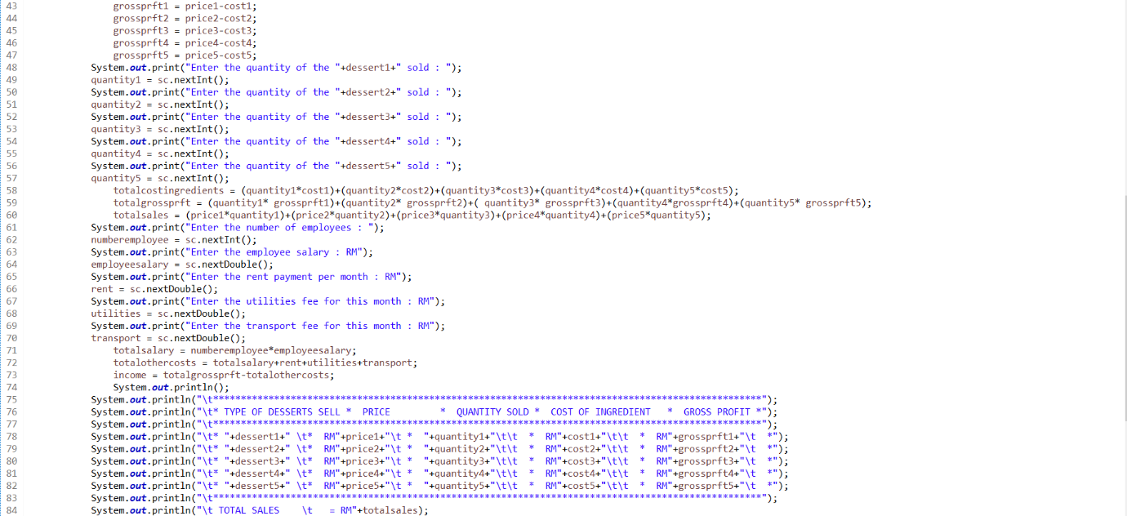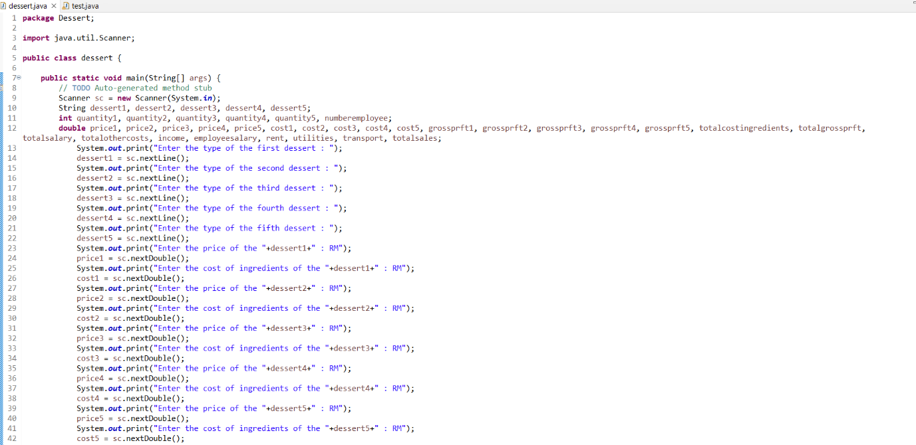**CODING**

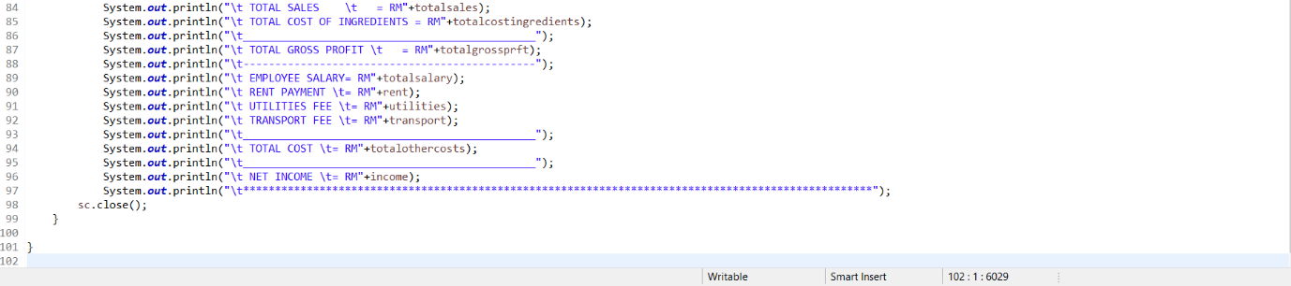

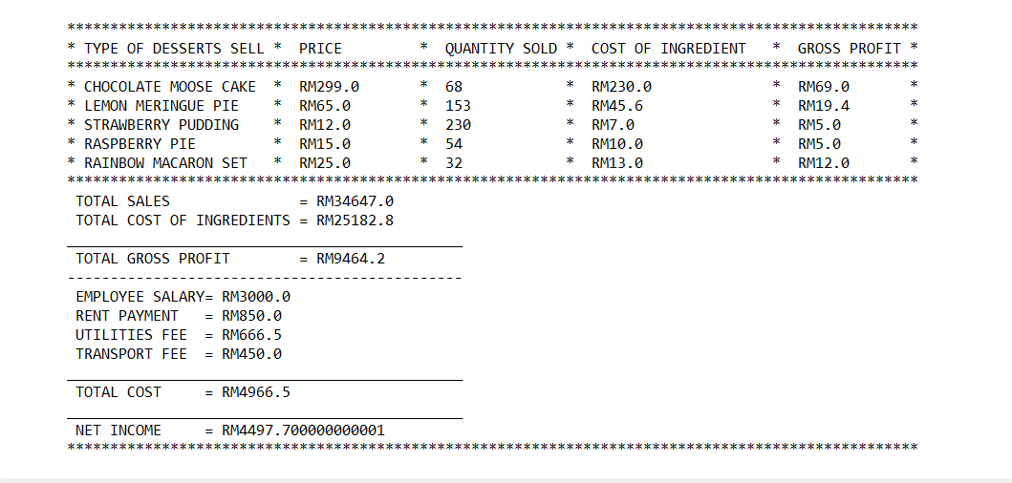**OUTPUT**

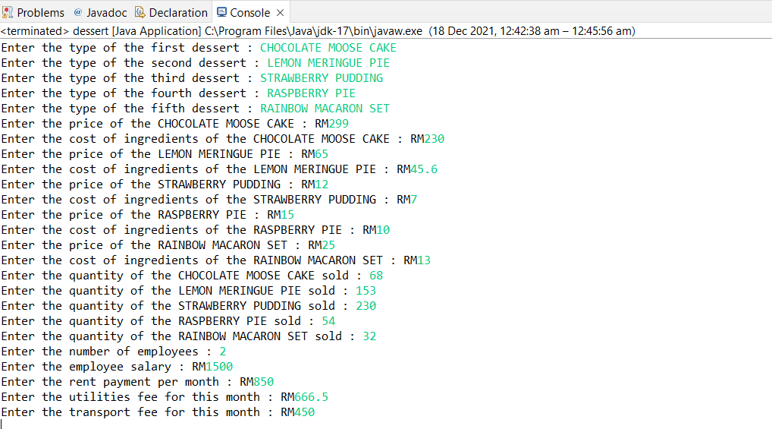



**SCHOOL OF LANGUAGES, CIVILISATION AND PHILOSOPHY**

**FIRST SEMESTER 2021/2022 (A211)**

**STIA113 PROGRAMMING I**

**TOPIC :**

FRUIT

**MADE BY :**

NURLAILATUL AQILAH BINTI NASIR (287438)

**LECTURE’S NAME:**

PROF. MADYA. DR. AZMAN BIN YASIN

1. **IDENTIFY THE PROBLEM:**

A fruit is seed-bearing structure in flowering plants that is formed from the ovary after flowering. Fruits are the means by which flowering plants disseminate their seeds. Following the three main modes of fruit development, scientist have classified fruits according to their various groups which are composite fruits, simple fruits, and aggregates.

Sin Seng Huat (SSH) is one of the pioneer crop production companies in Malaysia. Sin Seng Huat manufacture and distribute a wide range of high-quality products ranging from vegetables seeds, agrochemicals, agriculture implements and fertilizers. Their products are getting diverse to satisfy the agriculture business which is getting more challenging, modern, and growing demand annually. One of SSH seeds’ strengths is that they have their own R&C department, and they are partnering with 45 seed-breeders around the world.

1. **UNDERSTAND THE PROBLEM:**

A contracted farmer who is work with Sin Seng Huat wants to build a greenhouse contains with various type of fruits for a project that company already planned for. They do not want to extend their budget because of the cost building the greenhouse took a lot of money. The problem is the farmer do not know the whole cost that they need to use to buy the seeds to fill up the greenhouse with various type of fruits. Currently, the farmer is searching for sellers that selling a whole bundle of seeds with a reasonable price and having a good quality of seeds.

1. **IDENTIFY ALTERNATIVE WAYS TO SOLVE THE PROBLEM**

* Check an application that sells a bundle of seeds with a reasonable price.
* Go to check from store to store to compare the prices.

1. **SELECT THE BEST WAY TO SOLVE THE PROBLEM FROM THE LIST OF ALTERNATIVE SOLUTIONS**
2. The first solution is the greatest solution. Not only the farmer didn’t have to go out and check from store to store. It will be more less expensive and much a saving money solution. The application will also have a lot of benefits if a farmer decides to become a member or having an account in the application. The farmer also can make a budget while using the application so that they do not exceed their budget that they already set. The farmer can use the application to make their buying process to be much easier.
3. The second solution is not really recommended to a farmer since it will cost a lot of money to check from store to another store. It will cost a lot more because of the farmer has to refill their vehicle’s oil. It also wastes a time to search store one by one. What if they indeed found a good store but it already too late and the farmer might give up on planting in the middle of searching.
4. **LIST INSTRUCTIONS THAT ENABLE YOU TO SOLVE THE PROBLEM USING THE SELCTED SOLUTION**
5. A new user must make an account to use the application. They must key in the personal information such as full name, date of birth, gender, state etc.
6. A user can decide either they want to be a member of application or not. If they want to be a member, they must pay RM50 per year.
7. A user can enter the type of seeds that they want to buy.
8. After choosing the seeds, the user must add the seeds to cart to proceed to the payment session.
9. When the user adds all the seeds they want to buy at the cart, the cart will show the total amount they have to pay.
10. A user must choose the payment method to pay all the seeds, they can choose to pay using online banking or cash on delivery.
11. After paying the products, the application will automatically show the voucher that user get.
12. If the user is already registered member, the application will automatically give the user voucher RM5 off for the next purchase every time the user spent RM100 and voucher RM10 off, a new tool and free delivery if user spent RM300 and above.
13. If user is a new registered member, the application will automatically deduct the amount of the price with 25% discount because it is the benefit for the new user. But this benefit is only for the first time the user buys something.
14. **EVALUATE THE SOLUTION**

Based on the solution, the user as in the farmer can choose to a various type of fruits seed that the application offers with a reasonable price with a big amount. Besides that, the farmer also gets a lot of benefit from the application such as RM5 off voucher for next purchase if they spent minimum RM200 and RM10 off voucher for next purchase, a free new tool and free delivery if they spent above RM300. Even though, the user must pay RM50 every year to continue be a member of application. It brings a lot of benefits to user. The application will help farmer to save a lot of money without exceed their budget. Farmer definitely can save a lot of money if they use the application to buy the huge number of seeds. In conclusion, farmer will know how much worth it if they buy the seeds from the application is rather than checking up the store one by one. Not only, it is tiring but also farmer have to spend a money out of the budget to refill their vehicle’s oil.

FORMULA CALCULATION:

PRICE FOR SEED :

|  |  |  |
| --- | --- | --- |
| **Types of Seed** | **RM (200g)** | **RM (500g)** |
| Apple Seed | 60 | 110 |
| Strawberry Seed | 80 | 150 |
| Grape Seed | 50 | 100 |
| Orange Seed | 45 | 90 |

PRICE FOR PREMIUM SEED :

|  |  |  |
| --- | --- | --- |
| **Types of Premium Seed** | **RM (200g)** | **RM (500g)** |
| Apple Seed | 70 | 120 |
| Strawberry Seed | 90 | 160 |
| Grape Seed | 60 | 110 |
| Orange Seed | 55 | 100 |

|  |  |  |  |  |
| --- | --- | --- | --- | --- |
| SEED | AMOUNT | WEIGHT | FORMULA | PRICE |
| Apple + Orange | 2 + 1 | 200g | (Apple Seed*2) + Orange Seed  (RM60*2) + RM50 | RM170 |
| Strawberry + Grape | 1 + 1 | 500g | Strawberry Seed + Grape Seed  RM150 + RM100 | RM250 |
| Apple + Strawberry | 1 + 2 | Apple- 500g  Strawberry  –200g | Apple Seed + (Strawberry Seed*2)  RM110 + (RM80*2) | RM270 |
| Grape + Orange | 2 + 2 | Grape- 200g  Orange- 500g | (Grape Seed*2) + (Orange Seed*2)  (RM50*2) + (RM90*2) | RM280 |

Discounted Price for the new registered user :

|  |  |
| --- | --- |
| ITEMS | PRICE |
| 1. Apple + Orange | RM170 – 25% discount  = RM42.5  =RM170-RM42.5  =RM127.5  Price before discount = RM170  Price after discount = RM127.5 |
| 1. Strawberry + Grape | RM250 – 25% discount  =RM 62.5  =RM250-RM62.5  =RM187.5  Price before discount = RM250  Price after discount = RM187.5 |
| 1. Apple + Strawberry | RM270 - 25% discount  =RM67.5  =RM270 – RM67.5  =RM202.5  Price before discount = RM270  Price after discount = RM202.5 |
| 1. Grape + Orange | RM280 – 25% discount  =RM70  =RM280-70  =RM210  Price before discount = RM280  Price after discount = RM210 |

Total Price for the registered user :

|  |  |
| --- | --- |
| ITEMS | PRICE |
| 1. Apple + Orange | RM170  *The user did not get any discount because they did not spend until RM200* |
| 1. Strawberry + Grape | RM250  ** The user will get RM5 off voucher every time they spent RM200** |
| 1. Apple + Strawberry | RM270 |
| 1. Grape + Orange | RM280 |

1. **ALGORITHM**
2. Start
3. Enter the user’s name
4. Enter the user’s state
5. Enter the user’s gender
6. Enter the user’s age
7. Enter the type of seed user want to buy
8. Choose which either the user wants to purchase 200g or 500g seed
9. Enter the seed’s price that user choose
10. Enter the amount of bag user want to purchase
11. Enter the second type of seed user want to buy
12. Choose which either the user wants to purchase 200g or 500g for second seed
13. Enter the second type of seed’s price that user choose
14. Enter the amount of bag user want to purchase
15. The program will calculate the total amount of price
16. Choose either the user wants to be a member or not
17. The program will calculate the discount user get if they are new member
18. The program will show the total amount
19. End
20. **PSEUDOCODE**

Start

Output “Please enter your name”

Input enters user’s name

Output “Please enter your state”

Input enters user’s state

Output “Please enter your gender”

Input enters user’s gender

Output “Please enter your age”

Input enters user’s age

Output “Please enter type of seed you want to buy”

Input enters the seed’s name

Output “Choose either 200g or 500g”

Input users choose which one they want to purchase

Output “Enter the price of seed you want to buy”

Input users enter the price

Output “How many bag of seed you want to buy”

Input users enter the amount of bag

Output “Please enter the second type of seed you want to buy”

Input enters the seed’s name

Output “Choose either 200g or 500g”

Input users choose which one they want to purchase

Output “Enter the price of seed you want to buy”

Input users enter the price

Output “How many bag of seed you want to buy”

Input users enter the amount of bag

Output “The total price of your products”

Output “Are you a member ?”

Input user enters either yes or no

Output “Do you want to be a member ?”

Input user enter either yes or no

Output “Enter your name”

Input enters user’s name

Output “You have to pay RM50 per year to continue be a member.”

Output “You will get a RM5 off voucher for next purchase for minimum spending RM200”

Output “If you are spending RM300 and above, you will get a RM10 off voucher for next purchase, a new tool and free delivery.”

Output “You get RM… off”

Output “The final amount of your product’s price : …”

End

1. **FLOW CHART :**

Choose either 200g or 500g

Enter the type of seed

Enter the user’s age

Enter the user’s gender

Enter the user’s state

START

Enter the user’s personal information

Enter the seed’s price

Enter the amount of bag user want purchase

Calculate the final price = price1 * amount

Enter the amount of bag you want to buy

Enter the seed’s price

Choose either 200g or 500g

Enter the second type of seed

Calculate the final price2 =

price2 * amount

Enter the user’s name

Input Enter yes or no

Output Do you want to be a member ? 

Input Enter yes or no

Output Are you a member?

Calculate total =

price1 + price2

Output The final amount of your products’ price is …

Calculate finaltotal = total – discountreceived + 50

Output You get RM… off

Calculate discountreceived = (total*25) / 100

Output you will get RM10 off voucher, a free tool and free delivery if you spend minimum RM300 and above

Output you will get RM5 off voucher if you spend minimum RM100

Output You have to pay for RM50 per year to continue be a member

END

Output You get a RM5 off voucher

1. **CODING**

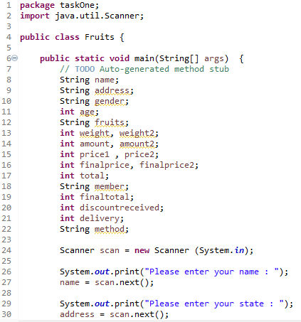

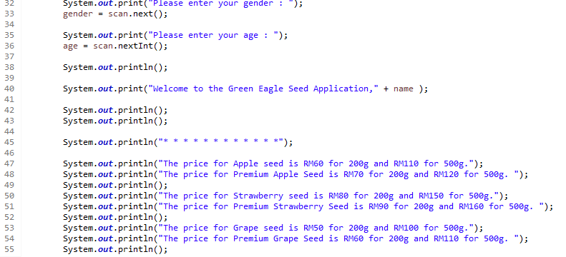

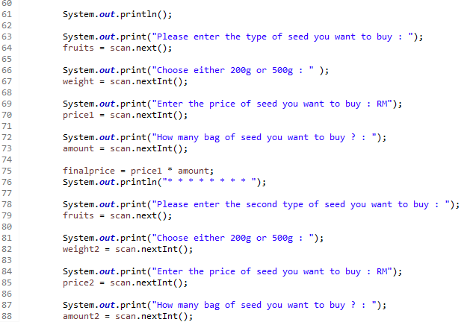

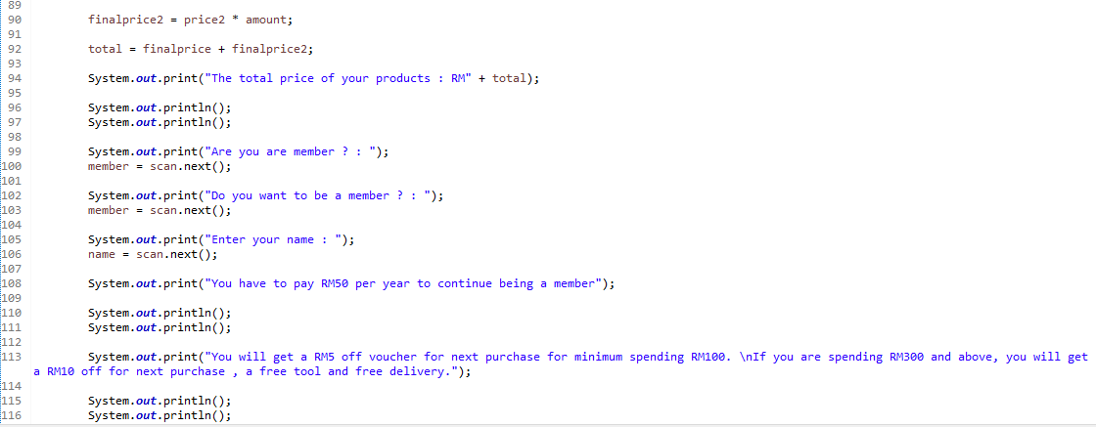

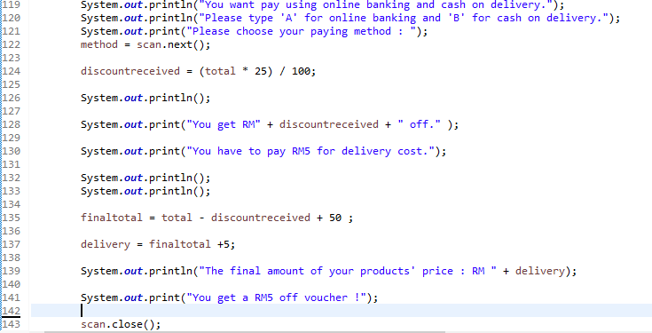

**Output Coding :**

